CS 3323
Assignment 1

Assignment 1
July 11, 2005

- Q1
Algorithm 1 has a running time of n²+2n, and algorithm 2 has a running time of 1000log₂n. Determine a value n₀ such that 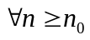, the running time of algorithm 1 is always greater than that of algorithm 2. Explain.
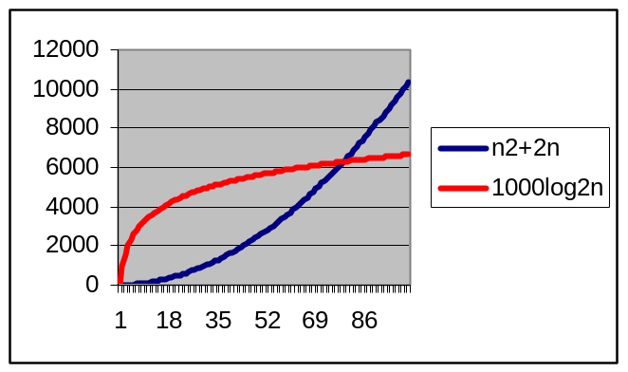
n | n²+2n | 1000log₂n
70 | 5040 | 6129.28302
71 | 5183 | 6149.74712
72 | 5328 | 6169.925
73 | 5475 | 6189.82456
74 | 5624 | 6209.45337
75 | 5775 | 6228.81869
76 | 5928 | 6247.92751
77 | 6083 | 6266.78654
78 | 6240 | 6285.40222
79 | 6399 | 6303.78075
80 | 6560 | 6321.92809

If we differentiate each fn. it is clear that at n=79, the function representing algorithm 1 is greater and is growing at a greater rate than the fn. associated with algorithm 2
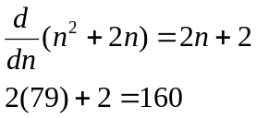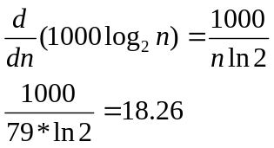

- Q2
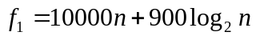
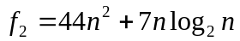
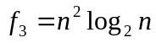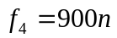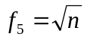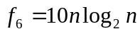
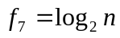

- Classify the given functions using the asymptotic big ‘O’ operator. You must simply order them correctly.
- Circle the functions whose running times fall into the same asymptotic category. i.e. any place the big theta operator can be used.
- From the sequence you obtained in part (a), prove the first big ‘O’ relationship.
Proof: log n 2 O(n^{1/2}).
substitute m= n^{1/2} or equivalently m²=n
log n=log m²=2log m
≤2m 8m≥1.: 8n≥1
=2n^{1/2}
.: 9c=2 and n₀=1 such that log n≤ n^{1/2} 8n≥n₀

- Q3
Consider the first five functions given in Q2. If these formulae correspond to the running complexity (in operations) of the five algorithms - A₁, A₂, A₃, A₄, A₅. Interpret the functions as follows: the number of operations performed by A₁ in processing n data elements is given by f₁.
Given three machines whose speeds are specified as follows, fill in the table below to specify the largest problem (largest n) that can be processed by each algorithm on each machine in one minute (60 Seconds). Scientific notation is acceptable for these answers, as some may be very large.
MACHINE 1: 10000 operations/sec
MACHINE 2: 1000 operations/sec
MACHINE 3: 100 operations/sec

 | MACHINE 1 | MACHINE 2 | MACHINE 3
A₁ | 59 | 5 | 0
A₂ | 116 | 36 | 11
A₃ | 272 | 95 | 34
A₄ | 666 | 66 | 6
A₅ | 360,000,000,000 or 3.6*10¹¹ | 3,600,000,000 or 3.6*10⁹ | 36,000,000 or 3.6*10⁷
Maximum number of data items processed by A₁- A₅ on MACHINE1-3

- Q4
  - State weather each of the following statements are true or false
    - 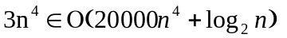
True
Proof:
try c=1
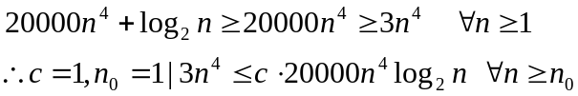
    - 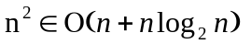
False
True
Proof:
try c=2
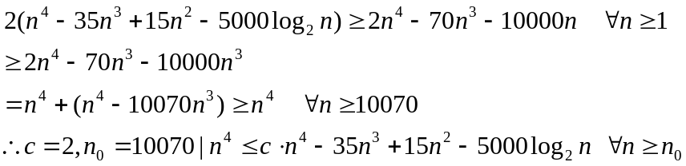

True
Proof:
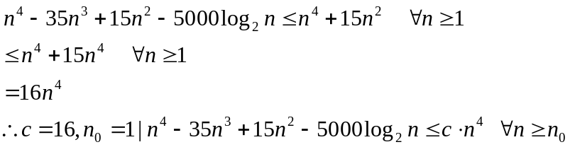

    - 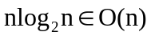
False
- Q5
Examine the following algorithm.
  - what is returned?
  - Specify the exact number of operations as a function of n. Consider each of the following as one operation: assignment, compare (<,>,==,>=,>=,!=), add, subtract multiply, divide, return statement.

Algorithm
Input: integer n
Output: ?

a← 0
b← 0
c← 0

while a<n do
while b<a do
c← c+5
b← b+1
a← a+2
return c
